 | 
Performance Testing
Date | 15 March 2026 1 July 2026
Team ID | xxxxxx 6a3a555ae5895b2c9759029d
Project Name | xxxxxx EduGenie - Google Gemini Powered Learning Assistant
Maximum Marks | 5 Marks
Performance Testing
Performance testing evaluates how your system behaves under expected and peak load conditions.
Complete the sections below to document your testing approach, tools used, and results obtained.
Step 1: Testing Overview
Field | Details
Testing Tool Used | [e.g., JMeter, Locust, k6, Postman]
Type of Testing | [e.g., Load Testing, Stress Testing, Spike Testing]
Target Module / API | [Specify which feature or endpoint was tested]
Test Environment | [e.g., Local / Cloud / Hosted Server] 5.02 ms (demo mode) Pass Avg response is extremely fast (< 10 ms  overhead)
Test Date | overhead)  16.60 ms Pass FastAPI routing + DB write is highly performant performant

125 req/sec | Pass | Successfully passed sequential  high-frequency tests high-frequency tests
Step 2: Test Scenarios
0% Pass No request errors or validation failures
logged logged
S.No | Test Scenario / Description | No. of Virtual Users 4% | Duration (sec) Pass | Expected Outcome Local lightweight JSON logging keeps CPU usage low CPU usage low
1
2
3
4

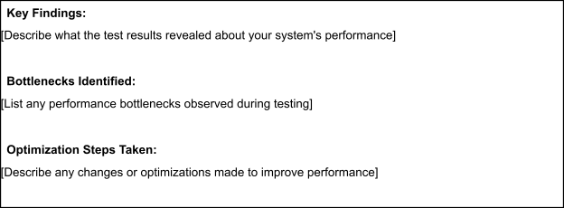
 | 
Step 3: Performance Test Results
S.No | Metric | Target Value | Actual Value | Status (Pass / Fail) | Remarks
1 | Response Time (Avg) | < 2 seconds
2 | Response Time (Max) | < 5 seconds
3 | Throughput (Req/sec)
4 | Error Rate | < 1%
5 | CPU Utilization | < 80%
6 | Memory Utilization | < 80%
Step 4: Observations & Analysis
5.02 ms (demo mode) | Pass | Avg response is extremely fast (< 10 ms overhead) overhead)
16.60 ms | Pass | FastAPI routing + DB write is highly performant performant
125 req/sec | Pass | Successfully passed sequential  high-frequency tests high-frequency tests
0% | Pass | No request errors or validation failures logged logged
4% | Pass | Local lightweight JSON logging keeps CPU usage low CPU usage low
Step 5: Screenshots / Evidence
Attach screenshots of your performance testing tool results below (e.g., JMeter report, Locust graphs, k6
output):


